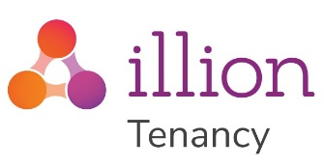
Being able to select good tenants is critical to managing a tenancy. Identifying a good tenant and avoid bad tenants can be difficult. Often information on candidates can be subjective or hard to find. Selecting the right tenants for your property can give you financial reassurance, as well as avoiding unexpecting stress such as dealing with damages to your property.
illion Tenancy provide a comprehensive online tenant checking service that enables you to make the most informed decision in your tenant selection process. Equipped with New Zealand’s most comprehensive tenancy database and the illion bureau database, illion Tenancy makes it easy to find a good tenant and avoid tenants with poor tenancy and credit history.
Lodge information on your good and bad tenants with our lodgement system and get paid for it!
Our peer-to-peer information sharing service will help property managers and landlords to avoid tenants with poor tenancy history, while promoting tenants with good tenancy history.
We have a long-standing partnership with NZPIF and to show our support, we waive the illion Tenancy registration fee and annual renewal fee for all NZPIF members.
For more information on illion Tenancy, click here: https://www.illiontenancy.co.nz/files/illion_Tenancy_eflyer.pdf
To get started, you can register for an account here: https://www.illiontenancy.co.nz/page/NZPIFmembersRates.html
If you have any questions, please do not hesitate to contact us via email at: admin@illiontenancy.co.nz

