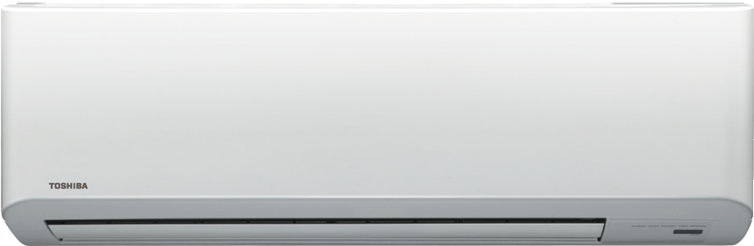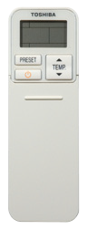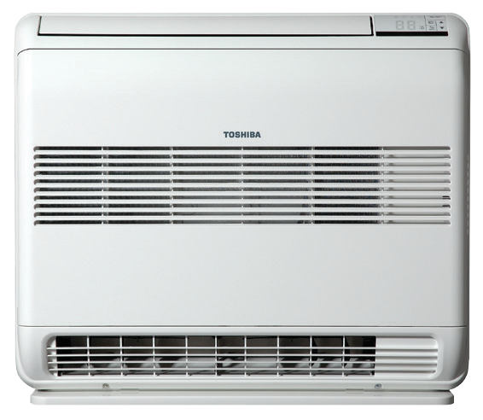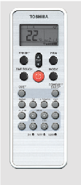
BIG SUMMER BLOWOUT
NEVER to be repeated prices. Beat the upcoming price increase.
Take the opportunity to secure one of these EXCLUSIVE DEALS on offer to NZPIF Members Nationwide.

BKV/N3KV2 Toshiba Hi Wall Range from $729+

Model | Heat Capacity (Range) | Price (Excludes GST)
BKV07 | 2.5kW (0.7~4.00) | $729
N3KV10 | 3.2 kW (0.9~4.80) | $839
N3KV13 | 4.2 kW (0.9~5.80) | $969
N3KV16 | 5.3 kW (0.9~6.30) | $1120
N3KV18 | 5.8 kW (0.9~6.30) | $1295
N3KV22 | 7.0 kW (1.0~7.50) | $1429
N3KV24 | 8.1 kW (1.6~9.00) | $1789
RB-RXS-30E | Optional Weekly Remote | $59

UFV Toshiba Compact Floor Console Range from $1149+

Model | Heat Capacity (Range) | Price (Excludes GST)
UFV10 | Heat 3.2 kW (1.0~4.80) | $1149
UFV13 | Heat 4.1 kW (1.0~5.40) | $1439
UFV16 | Heat 5.0 kW (1.1~6.30) | $1729
UFV18 | Heat 5.8 kW (1.1~6.30) | $1829

Conditions:
Deals strictly for NZPIF members nationwide.
Prices valid from 20th February 2017 till 24th March 2017.
All prices exclude GST and includes freight free delivery to Main Centres WHILE STOCKS LAST.

