FINAL
NEWS RELEASE
15 May 2014

Fit to rent? Housing WOF trial results released
The results of a rental housing ‘warrant of fitness’ field trial have been released. This is the first step in a collaborative project aimed at making rental housing safer, healthier and more energy efficient.
More than 140 rental properties were given the once-over by home assessment experts in Auckland, Tauranga, Wellington, Christchurch and Dunedin earlier this year. The pilot aimed to test whether draft WOF checklists and methodologies were practical for landlords, assessors and tenants.
The field trial has not resulted in the immediate issue of a WOF for each home but it is an important step towards standardising methodologies and checklists to ensure the credibility of any national WOF scheme.
The rental housing WOF field trial involved the Auckland, Tauranga, Wellington, Christchurch and Dunedin councils, the Accident Compensation Corporation (ACC), New Zealand Green Building Council and the University of Otago, Wellington. The trial tested a range of criteria that could potentially be included in a housing WOF. It aimed to identify aspects such as average assessment times and how to best communicate results to landlords and tenants.
The assessment tool was developed by the NZ Green Building Council and the University of Otago, Wellington, with feedback and input from the five councils, and ACC.
A spokesperson for the steering group behind the WOF survey trial, Dr Julie Bennett from the University of Otago Wellington, says work is now under way to tweak the WOF checklist. “We have received good feedback from landlords, tenants and the assessors and we are now going back to look at the checklist and criteria to make sure we have a robust and usable housing WOF for the rental market.”
Dr Bennett said landlords, assessors and tenants provided valuable information during the field trial. “The trial was really important so that we could gain an understanding about what is going to work for landlords, assessors and tenants. For a housing WOF to work it has to add value for the landlords and we needed to actually trial the draft WOF checklist and methodology.”
Some of the key information gathered from the field trial and subsequent interviews are:
- Landlords surveyed were supportive of a WOF in New Zealand.
- Landlords surveyed said that they were going to undertake work as a result of the new information from the draft WOF assessment.
- 36% of the homes that went through field trial would pass all of the draft WOF criteria with relatively minor fixes ($50 - $150 worth of materials/hardware perhaps).
Examples of items that are attracting most of the attention during this testing phase are whether houses need a ‘fixed’ form of heating such as a heat pump or a wood burner in order to ‘pass’ the WOF. Similarly, one of the requirements of the trial checklist was that all windows have ‘stays’ for security and to prevent children falling out – however due to difficulties in assessing these, and landlords saying that they were not keen on security stays, the steering group has agreed to drop them from the checklist.
After the inspection system has been refined it will be presented to the participating councils for discussion.
With a third of New Zealanders living in rental accommodation, the trial has made it clear that a rental housing WOF system would be highly useful to potential renters.
Mayor Stuart Crosby is very supportive of the trial. “This has been an important step in working towards a tool that will add value to both landlords and tenants.
“The Housing WOF would give prospective tenants the ability to make quick decisions about whether they want to further check out a property. Prospective tenants would be able to make calls as to whether a house is safe, healthy and energy efficient, making it warmer and more comfortable to live in. This would hopefully make tenants want to stay in their rental home for longer, benefiting both landlords and tenants.”
Most assessors who were interviewed after the trial said they were willing to make ‘easy’ fixes, while doing the inspections, to make homes compliant. The fixes included installing smoke alarms or smoke alarm batteries, changing lightbulbs or adjusting hot-water temperature.
Many homes still lack working smoke alarms – despite extensive and ongoing advertising – but the trial also found the overall condition of the homes that participated was good.
Around 94% of the homes inspected in the field trial did not pass at least one checklist criteria, but most dwellings failed on only a handful of the 31 inspection targets on the WOF checklist. Around 36% of homes would pass all the criteria in the draft WOF checklist after just a few minor and inexpensive fixes.
In terms of the next steps for the project, the partners in the project aim to:
- Share the results of the trial, including reporting back to relevant councils.
- Get endorsement/agreement from participating councils on the next steps.
- Continue discussions with Central Government to work towards one WOF tool for NZ.
- Finalise checklists and methodologies.
- Investigate next steps for introduction of a voluntary WOF scheme.

Facts and figures from the trial:
- 144 houses inspected.
- The inspection checklist looked at 31 items that covered a wide range of aspects ranging from weathertightness and insulation to ventilation, lighting, heating, condition of appliances and general building safety (see list).
- Age range from 1880s to less than 10 years old.
- Wide range of houses participated – from detached to apartments.
- Average time to inspect houses – 51 minutes.
- The majority of houses ‘failed’ on only a handful of checklist items.
- Top five checklist items that homes did not pass:
  - 40% of houses did not pass the water temperature check
  - 30% of bedrooms did not have a working smoke alarm within 3 metres of the bedroom
  - 31% of houses lacked code-compliant handrails and balustrades
  - 37% of houses did not pass the check for having a fixed form of heating

  - 38% of houses did not pass the security stays check

For further details please contact:
- University of Otago, Wellington – Dr Julie Bennett 021 321 993
- ACC - Glenn Donovan, tel 04 816 6591 ext 46591 or 027 504 3088
- NZ Green Building Council – Miranda James, tel 021 444 178
- Tauranga City Council – Michelle Elborn, 07 577 7363

Attachment 1

Assessment Criteria
1. Is there a functional, safe stove-top and oven? (Yes/no)

2. Is there adequate space for food preparation and storage? (Yes/no)

3. Is there an adequate supply of hot and cold potable water? (Yes/no)

4. Is the hot-water at the tap 55C (±5C?) (Yes/no)

5. Is there a functional toilet, which does not have a cracked or broken seat, cistern or bowl? (Yes/no)
6. Is there a suitably located bath or shower in good working order? (Yes/no)

7. Are there secure or high level cupboards or shelves for storing hazardous or toxic substances out of children's reach? (Yes/no)
8. Is there a fixed form of safe and effective space heating? (Yes/no)

9. Do the bathroom, kitchen and all bedrooms have some form of ventilation to outside? (Yes/no)
10. Is the house reasonably free of visible mould, i.e. the total area of mould is less than an

A4 sheet of paper? (Yes/no)

11. Are the power outlets and light switches safe and in good working order? (Yes/no)

12. Is there adequate indoor lighting? (Yes/no)

13. Does the house have adequate working smoke alarms? (Yes/no)

14. Have the windows got effective latches? (Yes/no)

15. Have high windows got security stays? (Yes/no)

16. Are there curtains or blinds in the bedrooms and living area? (Yes/no)

17. Do glass doors have safety visibility strips? (Yes/no)

18. Does the house have thermoplastic insulated cabling? (Yes/no)

19. Does the house have ceiling insulation to WOF standards? (Yes/no)

20. Does the house have underfloor insulation to WOF standards? (Yes/no)

21. Is the house weathertight with no evident leaks, or moisture stains on the walls or ceiling? (Yes/no)
22. Is a ground vapour barrier installed under the ground floor? (Yes/no)

23. Is the house in a reasonable state of repair? (Yes/no)

24. Is the storm and waste water drainage being adequately discharged? (Yes/no)

25. Is there any water ponding under the house? (Yes/no)

26. Is there adequate outdoor lighting near entrance ways? (Yes/no)

27. Does the house appear to be structurally sound? (Yes/no)

28. Are there handrails for all internal stairs and all outdoor steps that access the house, and do balconies/decks have balustrades to the current Building Code? (Yes/no)
29. Is there fire egress to the current Building Code? (Yes/no)

30. Is the address clearly labelled and identifiable? (Yes/no)

31. Are there securely locking doors? (Yes/no)

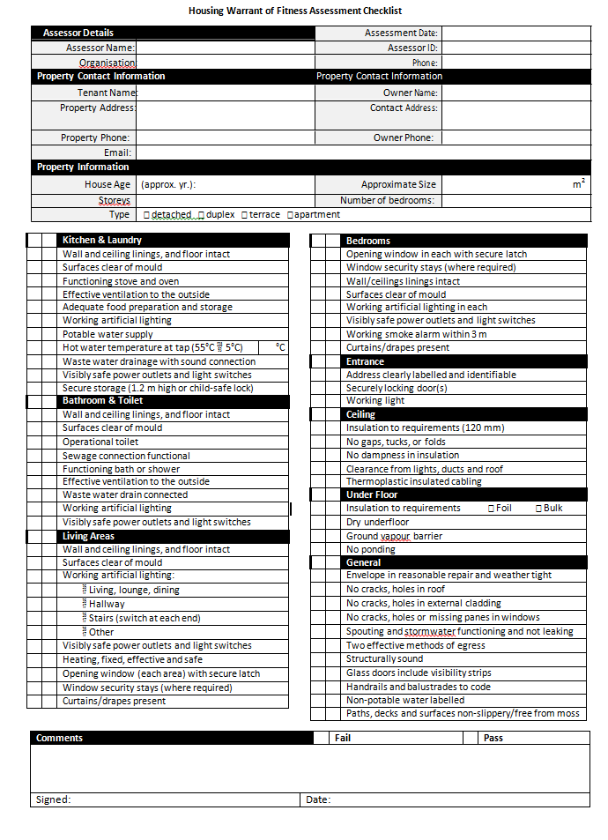

FAQ’s

- Why are the councils looking into developing a WOF for rental housing in the first place?
Housing is one of the key material determinants of health and well-being. New Zealand housing is of a lower quality than most OECD countries and several national surveys and research studies have shown that private rental housing is in poorer condition than either social housing, or houses that are owner occupied. Living in substandard housing is seriously damaging the health of New Zealanders with children from low-income families, Māori and Pacific peoples disproportionately affected. Over 70% of all children who are in poverty live in rental accommodation (20% in Housing New Zealand housing and 50% in private rentals).
Research has shown that, in general, rental houses have more quality issues (e.g. cold, damp, hard to heat) compared to owner-occupied and most vulnerable people live in rental housing. Cold and damp housing increases the burden of health issues and unsafe housing has led to more people being injured in the home than anywhere else.

Having a minimum “standard” would improve housing quality over time. The WOF should be considered as a tool that fits into a much broader, more comprehensive package to address housing quality.

Having a minimum housing standard provides an impetus for improved housing quality and therefore better health and reduced home injuries as well as greater energy efficiency.

More than one third of the roughly 1.7 million claims ACC receives every year are for injuries that happen in and around the home.

Injuries at home are caused by various factors, including behavioural and environmental factors, and it's the latter that the Warrant of Fitness will help identify.

We encourage people to look out for things such as adequate power outlets in rooms, so cords don't have to run across walk ways. Safe access to the front door is also important. The Warrant of Fitness looks for things such as well-structured steps, handrails and good outdoor lighting. Features such as these can all help to significantly reduce the risk of falls in and around the home, which lead to around 280,000 claims each year.

- Will the WOF be mandatory? Have any decisions been made?

No decisions have been made as to whether a WOF is voluntary or mandatory.

The WOF field trial was conducted on a voluntary basis. The councils do not have the ability to introduce a mandatory WOF scheme, only Parliament can do this by passing national legislation or a local bill.

At this stage the councils, ACC and its partners are proceeding based on the premise that the WOF is voluntary so that the rental market can use it as a standard assessment tool in order to raise the quality rental properties.

- What was the purpose of the WOF field trial?

The purpose of the field trial was to:
- establish the practicalities and utility of the draft rental Housing Warrant of Fitness assessment and checklist
- gather feedback from landlords, assessors and tenants to determine whether the draft WOF checklist and assessment procedure were workable and practical for landlords, assessors and tenants
- inform decisions about what changes need to be made to the draft WOF checklist and assessment procedures
- gather information on what the next steps are for the councils, ACC, NZ Green Building Council and the University of Otago.

- Central Government is also developing a WOF. What is the difference? How do the two draft WOF checklists compare? Are you looking to work together and develop one WOF?

Central Government is also considering implementing a WOF. However, at this stage Government is only looking at a WOF for Housing NZ properties.

The councils’ field test was conducted on private rental housing and council housing.

The Government’s draft checklist and the one used by the councils are very similar and mostly overlap. There are some differences such as:
    - the Government’s checklist assesses for the presence of vermin
    - the Council’s checklist has a minimum thickness condition for insulation
    - the Council’s checklist assesses homes for a “fixed form of heating” whereas the Government’s checklist assesses as to whether there is the ability to plug-in a heater

The councils, NZ Green Building Council and University of Otago are actively seeking to work in partnership with Government to create one WOF checklist and tool for all of New Zealand.

- How many homes actually went through the trial in each area? What was the average house age and size?
Region | Number of houses | House age mean (range) years | House size  Meanm² | Length of time to  conduct assessment
Auckland | 34 | 1973 (1950-2013) | 77 | 41 minutes
Tauranga | 25 | 1992 (1960-2013) | 109 | 59 minutes
Wellington | 39 | 1957 (1900-1998) | 93 | 52 minutes
Christchurch | 22 | 1967 (1930-1993) | 71 | 43 minutes
Dunedin | 24 | 1959 (1880-2009) | 109 | 60 minutes
Total sample | 144 | 1968 (1880- 2013) | 91 | 51 minutes

- How long did the assessments take on average?

On average just under an hour (51 minutes).

- What was in the draft WOF checklist? How thorough is the checklist?
  - See the press release above.
  - The draft WOF checklist in this field trial erred on the side of including additional criteria rather than excluding. The purpose of including criteria was to understand the practicality and value of assessing each individual checklist item to make informed decisions on what the final WOF checklist should look like.
  - Following the field trial, the checklist is going to be refined/updated to ensure the next version is more fit-for-purpose.
  - We were testing a range of criteria that could potentially be included in a WOF (as well as practicalities of the assessment), rather than a WOF.
  - We intentionally tested a broader range than what we anticipated being included in any future WOF, so that we could consider/select from a range of options.

- What were the high-level results using draft WOF checklist?
Of the 144 houses that were assessed eight houses (6%) passed all items on the draft WOF checklist. However, we found that many houses failed on low-cost or no-cost criteria.

Most houses passed most checklist items. If houses in this field trial fixed low-cost items (smoke alarms, security stays, hot water temperature) 44 extra houses would have passed the housing WOF assessment, which would have given a pass rate of 36%.

- What were the most common items that houses did not pass?

Low-cost
- 40% of houses failed for having their water too hot or too cold.
- 38% of houses failed for not having security stays on their windows.
- 30% of houses failed for not having working smoke alarms situated 3m or less away from the bedrooms.

More expensive items
- 37% of houses failed for not having a fixed form of heating.
- 31% of houses failed for not having handrails or balustrades up the Building Code Standards.
- 29% of houses failed for not having adeuqae ceiling insulation.

- Did any region perform better or worse than others?

There were no significant regional differences.

- How did landlords and tenants involved in the field trial feel about the WOF?

The majority of landlords that were interviewed are supportive of the idea of a WOF but they tended to have conditions with their support.

Most landlords interviewed
    - had a positive experience of the WOF field trial.
    - thought the WOF provided a fair and accurate assessment.
    - learned something from the WOF and planned to undertake improvements as a result.

The majority of tenants interviewed supported the idea of a WOF.

- What did you learn from landlords about the WOF that could be improved?

Some of the comments that we received from landlord about the booking process and process in general included:
- The WOF process needs clearer steps and longer timeframe to make an appointment.
- It would be easier if there was an electronic option for arranging assessments.
- It would be easier if assessor were more flexible in when they operated (i.e. undertaking assessments on weekends or outside the normal work day).
- Some assessors had to reschedule appointment times and this created more work for the landlord.
- More effort needs to be made to provide the WOF checklist in advance to landlords so they have a chance to make fixes before the assessment.
- Information on exact requirements (i.e. for where alarms go, insulation specifications, legal requirements) would be really helpful.
- It would be more convenient to conduct assessments between tenancies.
- It would be convenient to link the WOF assessment with regular tenancy inspection.

- Of the landlords surveyed, what items did landlords not like in the WOF?

- What is happening next?
The results of the field trial will be presented to all the participating councils and councils will need to take decisions on where to from here in terms of further testing and our efforts to collaborate with Government and policy decisions.

Options for next steps are:
- share the results of the trial, including reporting back to relevant councils
- get endorsement/agreement from participating councils on the next steps
- continue discussions with Central Government to work towards one WOF tool for NZ
- finalise the checklist and assessment method
- investigate next steps for introduction of a voluntary WOF.
- If the aim is healthy homes, why is there no meth contamination test?

Testing for drug manufacturing in houses is an extremely specialised area. If we were to test every house for drugs the cost of such a scheme would be prohibitive. Instead we think it is better to focus on the problems that most New Zealand houses face. If there is any suspicion that the house has previously been used to manufacture drugs then the assessors would recommend the owner get further more specialised drug testing done.

- Why does the test not take into account natural light, shelter and position? These all make a big difference to how warm the house will be?

Yes natural light, shelter and positioning of a house all influence how dry and warm a house is to live in. The housing WOF is only interested in items that landlords can change to make a difference to the health, safety and energy efficiency of the house. Unfortunately they can’t change the position a house has been built on. But is a house is badly positioned good insulation and heating is even more important.

- Who is responsible for mould if it's been caused by tenants drying clothes indoors and leaving the windows closed all year round?

The WOF focuses on the quality and safety of the house rather than tenants behaviour. We are strongly supportive of other initiatives that help educate occupants on ways to live in healthy homes. In the trial landlords commented that the WoF process would help them have constructive discussions with tenants.

- What would happen to properties that didn't get a warrant? If you couldn't rent them out legally, would a "black market" of cheap, unwarranted properties emerge?

We have not been issuing housing WOF or requiring that houses fix the items that failed in our trial. The trial has been about establishing the best criteria to have in a housing WOF. We are pleased to say that from this research the landlords involved were supportive of the idea of a housing WOF. The next steps after this trial includes looking further into issues of what might happen if houses fail and are not brought up to a safe, healthy, energy efficient standard.

- Why do councils think these half-hour inspections will cost around $200 when a 15-minute valuing inspection costs around $650?

The $200 cost is based off what trained assessors would charge to do the inspections. We are not sure how Valuers determine the costs of their inspections.

- How many people hours would it take to administer the scheme?

These details have not been established yet, as this trial was about testing the criteria, rather than the scheme.

- How will WOF information be made available? If there's no disclosure, anyone can claim to have one.
These details have not been established yet and will be investigated in the next stage. However, any formal WoF scheme would need to protect tenants against unscrupulous behaviour like that. Homes that pass would be logged onto an easily accessible website so tenants could look up the details. The information might also be kept by City Councils alongside details such as the house rateable value (RV).

Joint agreement for delivering a field test of a
Rental Housing Warrant of Fitness

